1. **Step 5: JwtAuthenticationFilter.java**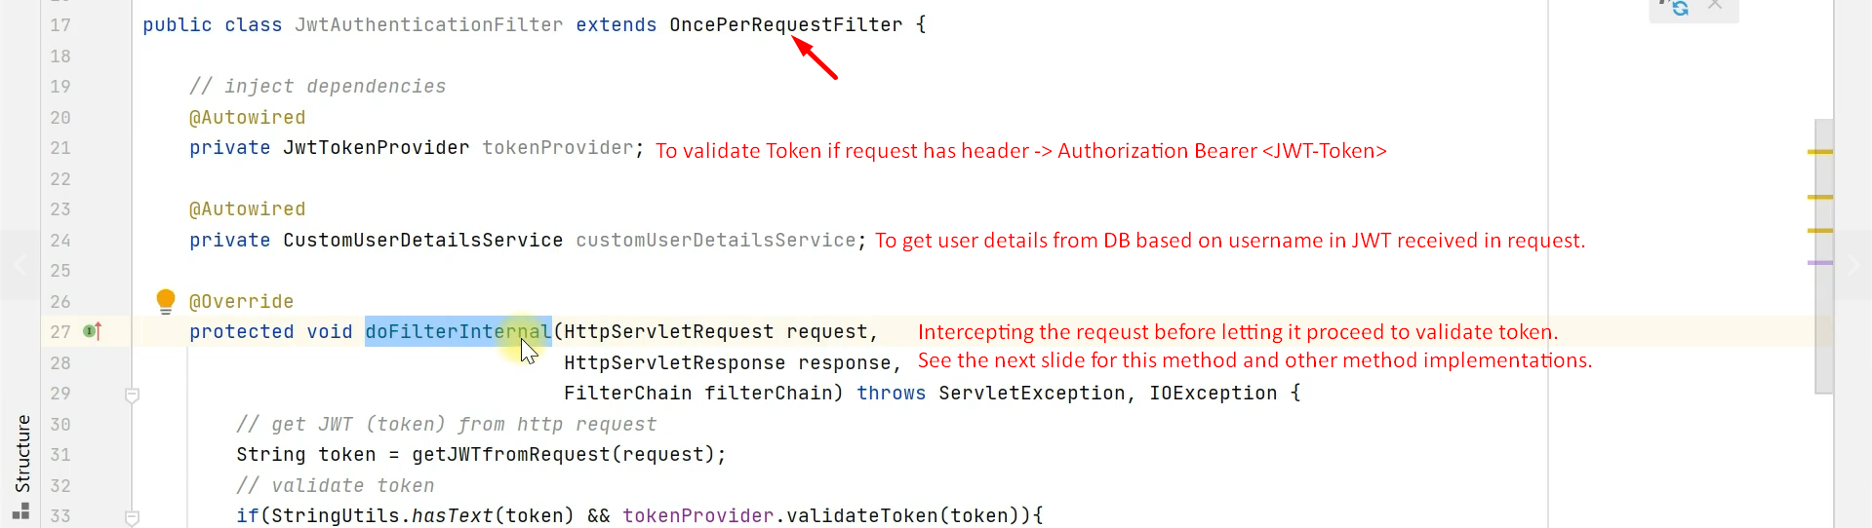
2. 